Enzyme Practice Quiz/Living Environment
1. Which of the following enzymes would digest a fat? (1.) sucrase (2.) fatase (3.) protease (4.) lipase
2. At high temperatures, the rate of enzyme action decreases because the increased heat (1.) changes the pH of the system (2.) alters the active site of the enzyme (3.) neutralizes the acids and bases in the system (4.) increases the concentration of the enzyme
3. Enzymes influence chemical reactions in living systems by (1.) providing the substrate required for the reaction to occur (2.) affecting the rate at which reactions occur (3.) absorbing water released when polymers are formed (4.) combining with excess hydrogen to form gaseous wastes
4. Which group of organic compounds includes the enzymes? (1.) proteins (2.) starches (3.) carbohydrates (4.) lipids
5. The "lock and key hypothesis" attempts to explain the mechanism of (1.) vacuole formation (2.) pinocytosis (3.) sharing of electrons (4.) enzyme specificity
6. Any substance that is acted upon by an enzyme is called a(n) (1.) coenzyme (2.) substrate (3.) vitamin (4.) polypeptide
7. An enzyme that hydrolyzes protein will not act upon starch. This fact is an indication that enzymes are (1.) hydrolytic (2.) specific (3.) catalytic (4.) synthetic
8. At 25 C. the optimum reaction rate of a certain enzyme occurs at a pH of 7. A greater reaction rate could probably be attained by (1.) increasing the temperature to 35 C and keeping the pH at 7 (2.) increasing both the temperature and the pH (3.) decreasing the pH and increasing the temperature (4.) increasing the pH and keeping the temperature at 25 C.
9. At about 0 C., most enzymes are (1.) inactive (2.) active (3.) destroyed (4.) replicated
10. Vitamins are essential to the survival of organisms because vitamins usually function as (1.) substrates (2.) nucleic acids (3.) coenzymes (4.) nucleotides
11. Which chemical is classified as an enzyme? (1.) galactose (2.) lipid (3.) protease (4.) manganese dioxide
12. Which element is present in maltase, but not in maltose? (1.) carbon (2.) hydrogen (3.) oxygen (4.) nitrogen
13. In enzyme controlled reactions, the role of certain vitamins such as niacin is to act as (1.) an enzyme (2.) a substrate (3.) a coenzyme (4.) a polypeptide
14. Salivary amylase is an enzyme in humans that breaks down starch. The optimum pH for this reaction is 6.7. The rate of this reaction would not be affected by (1.) maintaining the pH of the reaction at 6.7 (2.) substrate concentration (3.) enzyme concentration (4.) decreasing the temperature of the reaction by 5ºC
15. A certain enzyme will hydrolyze egg white but not starch. Which statement best explains this observation? (1.) Starch molecules are too large to be hydrolyzed. (2.) Enzyme molecules are specific in their actions. (3.) Egg white acts as a coenzyme for hydrolysis. (4.) Starch is composed of amino acids.
16. Which environmental condition would most likely have the LEAST effect on the rate of enzyme controlled hydrolytic reactions in humans? (1.) the pH of the solution (2.) the temperature of the solution (3.) the amount of enzyme present (4.) the amount of light present
17. Which statement best expresses the information represented in the graph shown?
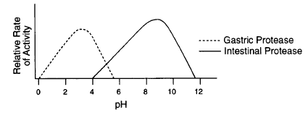
(1.) The action of enzymes varies with pH. (2.) A pH of 7 provides the optimum
environment for digestive enzymes (3.) Gastric juice is active at a pH extending from
0 to 12. (4.) Acids have a pH greater than 7.
18. Lipase, maltase, and protease are members of a group of catalysts known as (1.) hormones (2.) carbohydrates (3.) lipids (4.) enzymes
19. The effect of temperature on the relative rate of action of an enzyme is represented in the graph below.
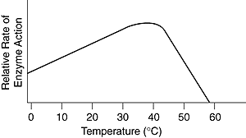
The optimum temperature for the action of this enzyme is approximately (1.) 15 C (2.) 22 C (3.) 37 C (4.) 50 C
20. Here are of some stages of an enzyme-controlled reaction .
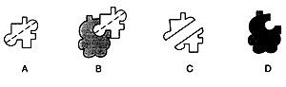
An enzyme-substrate complex is represented by diagram (1.) A (2.) B (3.) C (4.) D
Use the information provided in question 21 to answer questions 21 and 22 which follow.
21. The diagram below represents three steps in the hydrolysis of a molecule of sucrose.
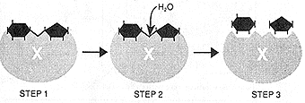
In this diagram, structure X is most likely (1.) a molecule of oxygen (2.) the end product (3.) an organic catalyst (4.) the substrate
22. List at least two reasons supporting your answer in question # 21.
Use your knowledge of the living environment and the diagram below to answer questions 23 through 25 which follow.
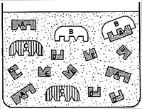
23. Which molecule is not associated with the reaction that is occurring in the solution? (1.) A (2.) B (3.) C (4.) D (5.) E
24. Which enzyme represents an enzyme functioning in this reaction? (1.) A (2.) B (3.) C (4.) D (5.) E
25. Using a complete sentence, explain why you chose the choice you made in question 24.
26. The fact that amylase in the human small intestine works best at normal body temperature suggests that (1.) amylase is denatured at temperatures below 37 degrees C (2.) amylase can function only in the small intestine (3) the lock-and-key model of enzyme action does not apply to amylase (4.) the optimum temperature for amylase is 37 degrees C
27. Hydrogen peroxide (H2O2) is a toxic by-product of cellular metabolism in aerobic organisms. The reaction shown occurs within the cells to prevent the accumulation of hydrogen peroxide.
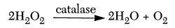
In this reaction, catalase functions as an (1.) indicator in the detection of hydrogen peroxide (2.) emulsifier in the digestion of hydrogen peroxide (3.) enzyme in the synthesis of hydrogen
peroxide (4.) enzyme in the breakdown of hydrogen peroxide
28. Which statement best describes the enzyme represented in the graphs below?
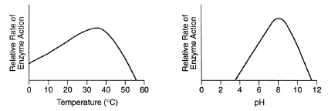
(1.) This enzyme works best at a temperature of 35 C and a pH of 8. (2.) This enzyme works best at a temperature of 50 C and a pH of 12. (3.) Temperature and pH have no influence on the activity of this enzyme. (4.) This enzyme works best at a temperature above 50 C and a pH above 12
Use the chart below and your knowledge of the living environment to answer questions 29 through 31 which follow.
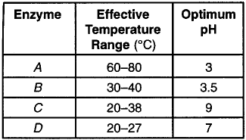
29. If enzyme C is functioning at 25°C and a pH of 7, under which conditions would the rate of enzyme action probably increase? (1.) The temperature is decreased to 22 C and the pH is kept the same. (2.) The temperature is kept the same and the pH is decreased to 6. (3.) The temperature is increased to 44 C and the pH is kept the same. (4.) The temperature is increased to 30 C and the pH is increased to 8.
30. At what temperature would enzyme D most likely be denatured? (1.) 15 C (2.) 20 C (3.) 25 C (4.) 39 C
31. Which enzyme would most likely be functional in bacteria living in a hot spring that is 35°C above normal human body temperature? (1.) A (2.) B (3.) C (4.) D
32. Which factor does not alter the rate of hydrolysis of maltose? (1.) temperature of the environment of the reaction (2.) pH of the environment of the reaction (3.) number of enzyme molecules present (4.) size of the substrate molecule
33. Which statement is a valid conclusion based on the information in the graph below?
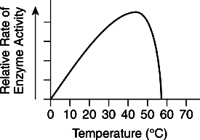
(1.) The maximum rate of human digestion occurs at about 45 C. (2.) The maximum rate of human respiration occurs at about 57 C. (3.) Growth can be controlled by enzyme action. (4.) Temperature can influence the action of an enzyme.
Use the equations below and your knowledge of the living environment to answer questions 34 and 35 which follow.
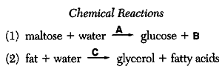
34. Letter A in chemical reaction one most likely represents (1.) a substrate (2.) a neurotransmitter (3.) an organic catalyst (4.) a hormone
35. Which substance most likely represents letter C in reaction two? (1.) amylase (2.) protease (3.) sucrase (4.) lipase
36. A student placed groups of 50 seeds in a variety of temperatures ranging from 0 to 50 C. A difference in the rate of germination observed in the groups at different temperatures was most likely due to the effect of temperature on (1.) ammonia (2.) acids (3.) enzymes (4.) cellulose
Free Response Section
1. Using your knowledge of enzyme structure and function, explain why a prolonged period of high fever is dangerous to humans.
2. Explain the Lock and Key Theory of enzyme function.
3. List three different factors which influence the rate of enzyme activity and specifically explain their influence on this activity.

Now hopefully some correct answers!
1. 4
2. 2
3. 2
4. 1
5. 4
6. 2
7. 2
8. 1
9. 1
10. 3
11. 3
12. 4
13. 3
14. 1
15. 2
16. 4
17. 1
18. 4
19. 3
20. 2
21. 3
22. The enzyme molecule X was unchanged in this reaction. Molecule X is a large molecule and enzymes are large protein molecules.
23. 3
24. 2
25. Molecule B is combining with molecule A to hydrolyze it to D and E. Molecule B is unchanged in this reaction. Both of these observations are consistent with the properties of enzymes.
26. 4
27. 4
28. 1
29. 4
30. 4
31. 1 (37 C + 35 C = 72 C)
32. 4
33. 4
34. 3
35. 4
36. 3
Free Response Section
1. A high fever will denature the enzymes in living cells. The cells will not be able to carry on their metabolic reactions and the human will ultimately die.
2. The Lock and Key theory of enzyme activity states that every enzyme has a specific shape which allows its active site to fit with a specific substrate. (This theory has been modified slightly by the induced fit hypothesis which states that an enzyme can change its shape slightly to accept a fit with a substrate.)
3. One factor influencing enzyme activity is pH. The optimum (best) in most
living things is close to 7 (neutral) -- high or low pH levels usually slow
enzyme activity. A second factor influencing enzyme activity is temperature.
The optimum temperature for maximum enzyme function is usually about 35-40 C.
As the temperature decreases below optimum, reactions proceed ever more slowly.
At temperatures above 45 C. most enzymes are denatured (change in shape so their active site no longer fits with the substrate). When there is a fixed amount of enzyme and an excess of substrate molecules -- the rate of reaction will increase to a point and then level off.
This leveling off occurs because all of the enzyme is used up and the excess substrate has nothing to combine with. If more enzyme is available than substrate, a similar rx. rate increase and leveling off will occur. (The excess enzyme will eventually run out of substrate molecules to react with.)

